

2020-2021 SAT Test Dates

Register for the SAT
- Register for the SAT HERE.
Don't forget to print your ticket!

SAT/ACT Test Prep Resources:

Access resources HERE!

***STAY TUNED FOR UPDATES ABOUT THE ACT BOOTCAMPS WE HAVE ON OUR CAMPUS!

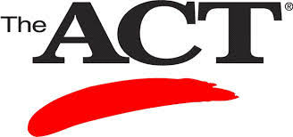

2020-2021 ACT Test Dates

Register for the ACT
- Register for the ACT test HERE.
Do not forget to print your ticket!

